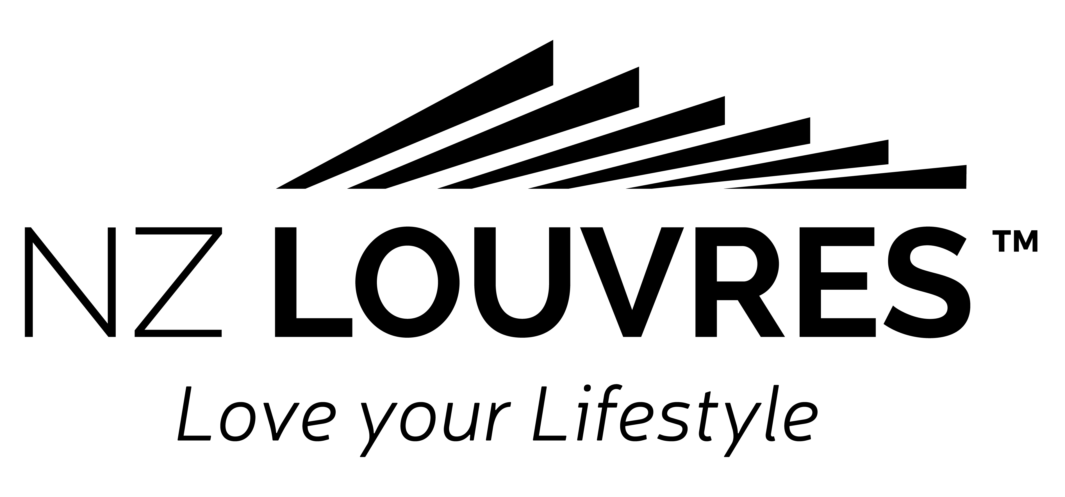
DRESS STANDARD POLICY

BETWEEN
[Registered Company Name] (the Employer)
AND
[Employee Name & Surname] (the Employee)

Policy Statement
At [Registered Company Name] we believe in being professional in all areas and this extends to the personal presentation of everyone working at [Registered Company Name].
[Registered Company Name] supplies company clothing to the installers and workshop which must always be worn. For sales and administration, our dress code always requires you to maintain a high standard of dress.
This extends to your personal appearance, which is of importance when representing the company in the public eye. The dress code also supports our Health & Safety policy.

Purpose
Our dress code has been established to support and assist us in meeting our Health & Safety responsibilities and ensure we always maintain our professional image.
Whilst we have outlined some dress standards, they are in no way intended to be complete, but instead should be treated as general illustrations of a concept.

Standards
General Standard of Dress
It is very important that, as representatives of our company, you are well presented, tidy and clean. Where a uniform is provided, it should be worn correctly, safely and appropriately, so that you present the best possible image to our customers. At all times it is to be clean.

Acceptable Standards
· Employees are expected to wear clothing of a reasonable standard, appropriate for their role.
· Employees should wear fully enclosed footwear appropriate for their role. Footwear must be safe, sensible, in good order, smart and clean and have regard to Health & Safety considerations.
· Employees should present as tidy and clean.

Unacceptable Standards
· Clothing bearing inappropriate slogans
· Tank tops, cut-offs, track suits, mini-skirts and strapless items
· Open toed shoes and jandals

Personal Protective Clothing and Equipment
Personal protective clothing and equipment is made available to employees in accordance with hygiene and safety standards.
Staff in roles that require protective clothing are required to wear this whilst carrying out their duties in accordance with health & safety requirements.
If individuals are unsure about such requirements, they should discuss this with their Manager.
Steel cap safety boots are to be worn in the workshop and on sites. The employee shall supply the first pair upon starting employment and then after a minimum of 12 months of employment, [Registered Company Name] will pay up to $170.00 per annum for a new pair.
If individuals are unsure about such requirements, they should discuss this with their Manager.
Hi-viz vests, ear muffs and safety glasses are available to office or admin staff if going into workshop or sites.

General Grooming
General Hygiene
Good, effective personal hygiene is required. In your job, you will come into close contact with people! Personal grooming and hygiene are very important. Just think about how you’d feel if someone in close proximity to you had bad breath, dirty nails and body odour.

Hair
Hair should be kept neatly styled and facial hair to be kept well groomed. Shoulder length (or longer) hair must be tied back away from the face (for Health & Safety purposes).
Jewellery
Jewellery is permissible in moderation. Jewellery should be discreet and appropriate so as not to cause offence or become a Health & Safety hazard.
For hygiene and Health & Safety reasons, you should refrain from wearing bangles and bracelets during working hours.
Tattoos and Piercings
Tattoos are acceptable providing they are not offensive otherwise Senior Management approval will be required and may require covering while wearing the uniform or representing the company on business – they must always be covered.
Any form of visible body piercing (except the ear lobe and nose) is not allowed on duty. Tongue piercings should also not be visible or (if visible) removed during working hours.
This policy document will be included in the Staff Policy & Procedures manual.
Any complaint about standards of dress in the workplace shall be made to the Manager who will arrange for the complaint to be investigated and, if it appears that a contravention has occurred, attempt to resolve the complaint within 7 working days.

Name: ____________________________________

Role: ______________________________________

Signed: ____________________________________

Date: ____________________

